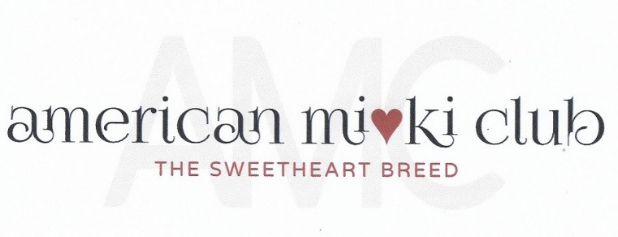
September 19, 2023
Board Meeting Minutes
Via Zoom Video Conference

- Opening Actions:
  - Meeting was called to order at 5:15 P.M Mountain Time.
Attendance:
President: Mary Parker
Vice President & Specialty: Susan Versmesse
Treasurer: Becki Thomason
Recording Secretary: Tina Cleveland
Director 1: Linda Elliott
Director 3: Tamara Beebe

  - Review of the Agenda. No additions.
- Officer’s Reports:
  - Minutes from September 2023 prepared by Tina Cleveland unanimously approved.
  - Treasurer’s Report, Becki Thomason. $ 2123.64 balance.

  - Membership Report: Bonnie Thompson.
N/A

  - Specialty: Sue Versmesse:
The IACBA show is scheduled for October 14, 2023 in Xenia, OH. Sue has all the prizes ready for best in show and reserve best n show. She also has the bags and stuff to fill them with. Receipts will be sent to Becki. Jennifer paid for most of the items.

  - Website Report: Mary Parker
Mary has made some little tweaks.
  - Health Report: Geri Wojeck
No updates.

- Old Business
Chiropractic class has been scheduled for Dec 12.
- New Business

- Closing Business
  - Next meeting is scheduled for September 19, 2023 at 7:00 PM Eastern time.

  - Motion to adjourn from Sue. Seconded by Tina at 8:30PM. All in Favor.

