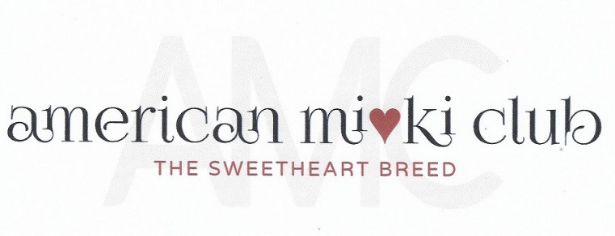
June 28, 2023
Board Meeting Minutes
Via Zoom Video Conference

- Opening Actions:
  - Meeting was called to order at 7:11 P.M. Eastern Time.
Attendance:
President: Mary Parker
Vice President & Specialty: Susan Versmesse
Treasurer: Becki Thomason
Recording Secretary: Vacant
Corresponding Secretary: Bonnie Thompson
Health Director: Geri Wojeck
Director 2: Barbara Briggs
Director 3: Tamara Beebe

- Officer’s Reports:
  - Minutes May Minutes will need to be recreated from memory as we’re unsure if Tina Cleveland will be able to send the recording of our last meeting and needed to resign. We sent a flowering plant in memory of her mother.
  - Treasurer’s Report, Becki Thomason.
$2,611.57 balance. Becki has not been able to figure out how to reimburse the expenditure for the gift. She is still figuring out how to get Stripe and the bank account to function together. As well as the GoDaddy account. To get an AMC bank account, we need an EIN (in process) and supply the bank with copies of our bylaws and our minutes must reflect three people who are officially authorized to access banking issues.

  - Membership Report: Bonnie Thompson.
MemberSpace account has been fixed. Becky is working to help clarify who has paid. Some applicants were missed due to an incorrect email for Bonnie. Jannette Hankins tried to apply but it was returned. Also, the Breeder Membership was accidentally assimilated into the Kennel Listing Page, so we need to figure out how to make two forms and how to put the Breeder Membership in their own area on the website (rather than just the minutes.) Mary will send Bonnie the MemberSpace Password.

  - Specialty: Sue Versmesse:
Unfortunately, Jean Perro isn’t available to judge our specialty. We don’t know any of the seven judges. We will reach out to Jean and Becki to see which judges they recommend. Sue will send the judge’s list to the AMC board. Sue and Jennifer have been picking up prizes here and there. Sue needs the embroidery file from Mary of our logo for the chairs. Wondering if we still want to do scholarships for the entry fees. October 14th. Dayton and Cincinnati are the closest airports. That information is on the website.

  - Website Report: Mary Parker
Mary has the health and Mi-Ki “Barks and Brags” forms on the website. She is figuring out how to report to the board where they are going. Minutes and Breeder membership pages need to be updated by Mary.

  - Health Report: Geri Wojeck
Geri has a rough draft on liver problems.
- Old Business
Becki asked her chiropractors to do an educational class for us. They are willing to do this and have a studio that they film their educational videos. Price wasn’t discussed. We would like about 30 minutes to an hour. It could be live or prerecorded. They talk about a variety of things including nutrition so we can restrict it to whatever we’d like. I think we paid about $200 to the Midwoofery lady and she also got referrals from our members. They enjoy working on the Mi-Kis because they are easy to handle and tolerate the adjustments well. She will get it set up and we can decide if it’s prerecorded or do it live and do live questions. She will ask if there is a price difference between doing a live vs. a prerecorded session.
4. New Business
- Sue and Mary gave an informal report on the UKC Top 10 and Premier 2023 Event.
- AMC Checking account authorization. Susan Versmesse motions to appoint Rebecca Thomason, Mary Parker, and Bonnie Thomson to be the authorized signers of the Wells Fargo American Mi-Ki Club Checking Account. Unanimously accepted.
- Discussion initiated by Becki regarding compensating club members who go to UKC’s Premier Top Ten to show appreciation for representing the breed at that large venue. Bonnie motioned that the the Club will start a scholarship of $100 per club member who is invited and attends the UKC’s Top Ten Premier dog show retroactively to June 2023. Unanimously approved. We need to do a blast about the Scholarship Recipients and participants.
- Closing Business
  - Meeting adjourned at 8:00 P.M. Eastern Time.

