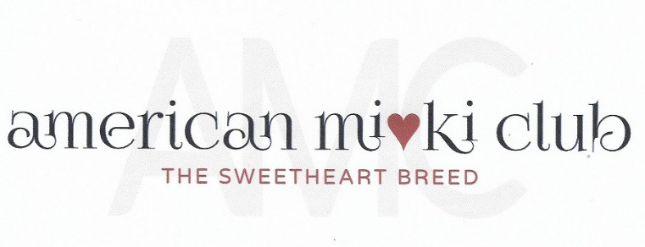
January 17, 2023
Board Meeting Minutes
Via Zoom Video Conference

- Opening Actions:
  - Meeting was called to order at 5:14 P.M. Mountain Time.
  - Attendance:
President: Mary Parker
Vice President & Specialty: Susan Versmesse
Treasurer: Rebecca Thomason
Recording Secretary: Tina Cleveland
Corresponding Secretary: Bonnie Thomson
Health Director: Geri Wojeck
Director 1: Linda Elliott
Director 2: Barbara Briggs
Director 3: Tamara Beebe

  - Review of the Agenda. No additions.
- Officer’s Reports:
  - Minutes from 20 December 2022 prepared by Mary Parker. Motion from Sue Versmesse to accept the minutes as published. Seconded by Tamara Beebe. Unanimously
accepted.
  - Treasurer’s Report, Becki Thomason.
Available balance $1,947.89. Accounts are being transferred from Andrea to Becky.

  - Membership Report: Bonnie Thompson.
    - Some members are having trouble with log-in. This issue is being worked on.
    - New applications will be reviewed and it will be determined where we currently are. The by-laws will be checked to see what needs to be done regarding membership renewals. A decision needs to be made regarding a change from a January 1 renewal to a subscription.
    - Bonnie will create an Excel spreadsheet of members. Announcements will be sent out to members who may want to be breeder members.
    - It would be helpful for new members to receive a “welcome to the club” package. Maybe this could be sent automatically when someone joins the club.
    - Consider setting up a lifetime membership with special rates for retired breeders.

  - Specialty: Sue Versmesse:
    - IABCA calendar dates for 2023 have been posted.
    - Here is the link for the IABCA Calendar: https://iabca.com/calendar.html
    - First choice is October 14-15, 2023 at Xenia, Ohio. Sue will research this venue.
    - Help is needed on this committee. Mary will help with bags.
  - Website Report:
    - Updated officer information has been posted. Email addresses have been linked to names.
    - There is a new Blog on the website for the case study on the frozen sperm puppies. Photos are needed of the puppies.
  - Health Report:
    - Geri is working a new health blog.

- Old Business
  - We need to get started on committee assignments and recruiting general club members who may want to be involved.
  - Looking for a current or former board member (Pat??) to be on the By-Laws Committee. Mary volunteered to help on this committee.
  - Bonnie will eventually need help with membership activities.
  - Determine which Liaison Positions are important. Tamara for AMRA, Traci Lennon for International, and perhaps others. The liaisons would be able to attend board meetings, but will not have a vote.
  - Sue will be needing help with Specialty Committee activities. We could have a 50/50 drawing to raise funds for rescues. Determine prizes. Mary will help with bags.
  - How can we get the word out about the club via social media or email? Can we get a social media coordinator? Facebook AMC pages are not being worked on.
  - Looking for ideas of what to post on Instagram. New content is needed to keep people coming back.
  - It would be nice to be able to print the AMC trifold directly from the website.
  - Having a resource section on the website with printable club materials would be helpful. Mary suggested using a QR code for Mi-Ki information.
  - The food issue keeps coming up. People want breed specific recommendations. Mary will get in touch with Ji Khalsa.
  - There was a discussion regarding having a class on taking care of yourself as a breeder to avoid burnout.
- New Business
- No new business.

- Closing Business
  - Next meeting Tuesday, February 21, 2023.
  - Meeting adjourned at 6:15 p.m.

