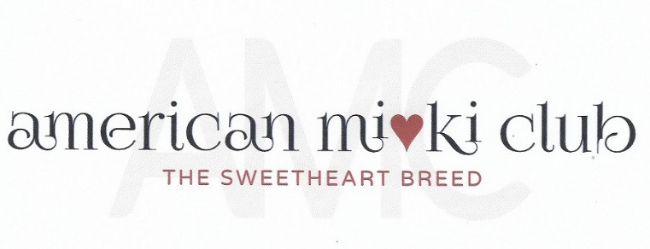
April 18, 2023
Board Meeting Minutes
Via Zoom Video Conference

- Opening Actions:
  - Meeting was called to order at 7:11 P.M. Eastern Time.
Attendance:
President: Mary Parker
Vice President & Specialty: Susan Versmesse
Recording Secretary: Tina Cleveland
Corresponding Secretary: Bonnie Thompson
Health Director: Geri Wojeck
Director 1: Linda Elliott
Director 2: Barbara Briggs
Director 3: Tamara Beebe

  - Review of the Agenda. No additions.
- Officer’s Reports:
  - Minutes from 21 March 2023 prepared by Tina Cleveland. Motion from
Linda to accept the minutes as published. Seconded by Barb. Unanimously accepted.
  - Treasurer’s Report, Becki Thomason.
$2,128 balance. Approximate expenditures are for ribbons ($280). Reimburse Sue.
Mary donates bags. UKC director did not get back to Mary.

  - Membership Report: Bonnie Thompson.
MemberSpace account was cancelled due to lack of payment. Bonnie will get this corrected. Letters are being sent to those members that haven’t renewed in a long time. Still working on membership. We need to determine which breeders on the Breeder’s List are still active.

  - Specialty: Sue Versmesse:
The IACBA show is scheduled for October 14, 2023 in Xenia, OH. It will be promoted on Facebook and the AMC website. Still looking for suggestions for items for gift bag.

  - Website Report: Mary Parker
Mary has been working on forms to put up on the website for reporting health issues and for Barks and Brags.

  - Health Report: Geri Wojeck
Geri has a rough draft on liver problems,

- Old Business
Becki asked her chiropractors to do an educational class and they are open to the idea.
- Closing Business
  - Meeting adjourned at 8:00 P.M. Eastern Time.

